R&D PROJECT EXPERIMENT AND TEST REPORT
DATE OF TEST:
August 2025
R&D PROJECT:
LithoSpace – Extraterrestrial Geochemistry Data Platform
EXPERIMENT/TEST NO: 002
R&D CORE ACTIVITY:
Cross-Rover Martian Dataset Visualisation
HYPOTHESIS ASPECT TESTED:
That heterogeneous Mars rover data from Curiosity, Pathfinder, and Perseverance can be visualised side-by-side using a unified schema, enabling automated comparison of major element distributions, terrain types, and potential biosignature markers.
DESCRIBE HOW EXPERIMENT/TEST UNDERTAKEN:
Building on 2023–24 visualisation tests using Curiosity data alone, the team harmonised and ingested rover datasets from Pathfinder, Spirit, Opportunity, and Perseverance. Instruments included APXS, PIXL, and SAM outputs and included all major oxide chemistry.
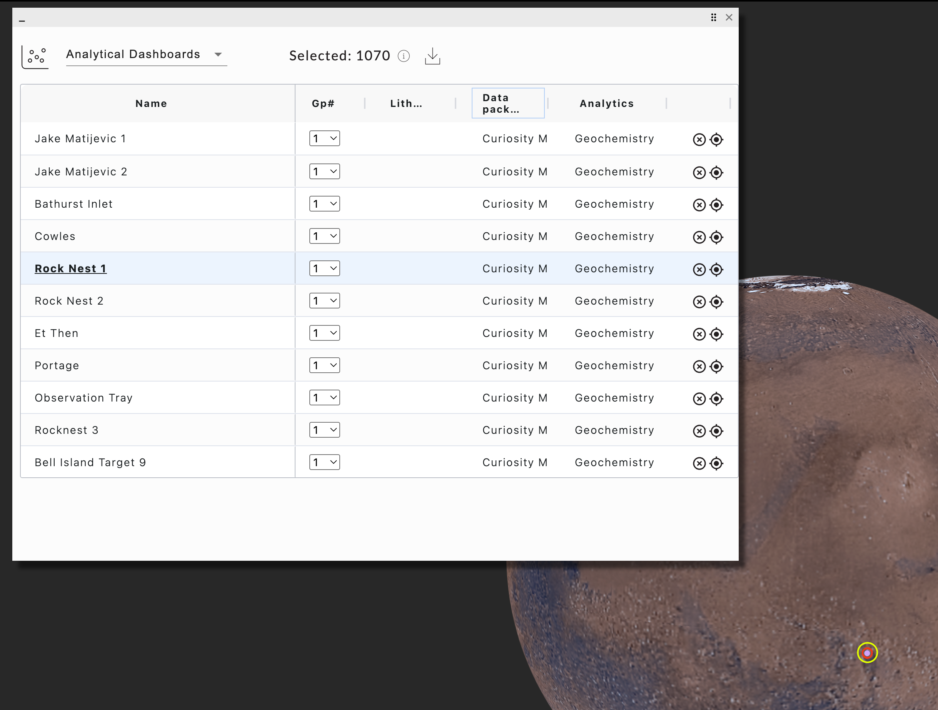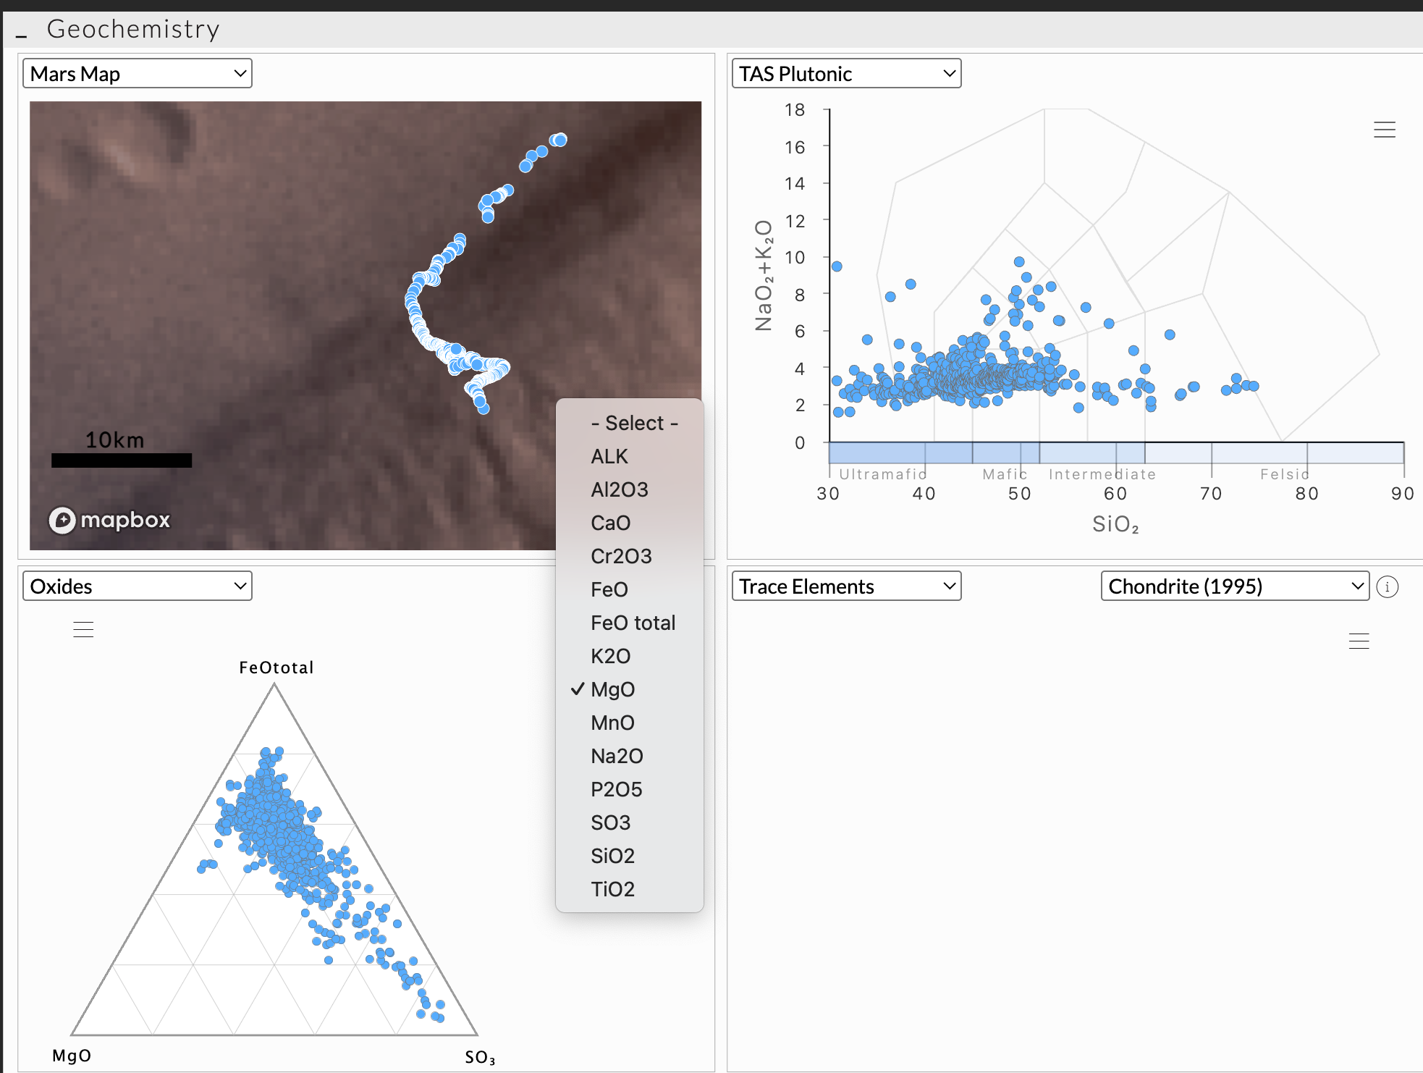
Data were standardised using the Mars ingestion schema designed this year, with coordinate referencing via IAU2000 ellipsoid. Dashboards were developed to allow users to toggle between missions and visualise trends in S, Cl, K, Fe, and sulfate concentrations.
TEST EVALUATION CRITERIA:
1. Successful ingestion of all four rover missions into one schema.
2. Ability to generate rover-by-rover dashboards.
3. Elemental comparison fidelity (sample location, wt% oxides.).
4. Available mission overview, reports and comment from lithospace community
TEST RESULTS:
1. Data from Pathfinder, Spirit, Curiosity, and Perseverance fully harmonised.
2. Interactive dashboards allow filtering by site, mission, and geochemical marker.
3. Anomalies in Cl and S mapped across regions; rover paths georeferenced accurately.
4. Positive reviews from RMIT planetary science reviewers, who praised ease of use and clarity.
TESTING CONCLUSIONS:
1. LithoSpace now supports multi-mission, multi-rover Martian analysis.
2. Cross-comparison tools can support future AI classification and biosignature detection.
3. All logic from Apollo ingestion engine successfully adapted to Mars data.
4. Schema allows future integration with Perseverance return samples.
EVIDENCE COLLECTED:
- Pathfinder–Perseverance datasets
- Mars schema definition
- Rover map overlays
- Dashboard visuals
- RMIT academic reviews
- GitHub logs for ingestion pipeline

